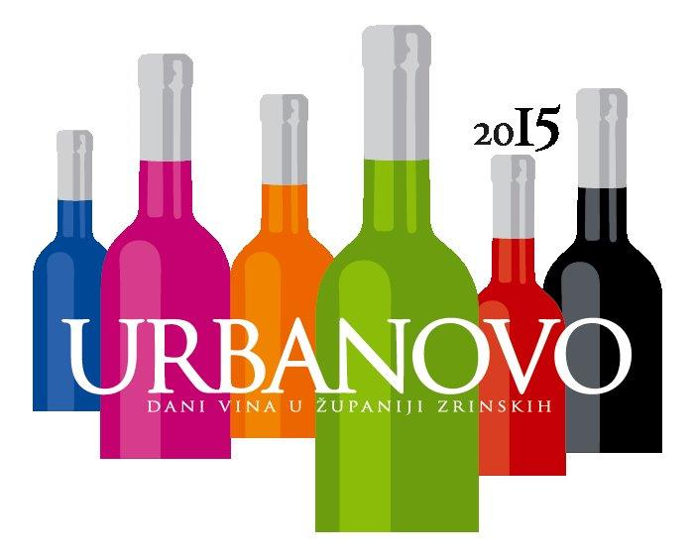**URBANOVO 2015**

**PRIJAVNICA ZA MEĐUNARODNO OCJENJIVANJE VINAPUŠIPEL/ŠIPON/FURMINT -**

**BEST OF PUŠIPEL/ŠIPON/FURMINT –**

**URBANOVO INTERNATIONAL WINE COMPETITION APPLICATION FORM**

|  |  |
| --- | --- |
| **PODACI O PRIJAVITELJU/INFORMATION ABOUT APPLICANT** | |
| ______________________________________________________________________________________________________________________________________________________________________________________________  Ime i prezime ili naziv poduzeća (za upis u katalog ocjenjivanja)/First and last Name or Company Name (for catalogue) | |
| _______________________________________________________________________________________  Ulicakućnibroj/Address | _______________________________________________________________________________________________  Broj pošte, pošta i država/Postal/ ZIP Code, City, Country |
| _______________________________________________________________________________________  Telefon/Telefon | _______________________________________________________________________________________________  Telefaks/Fax |
| _______________________________________________________________________________________  Kontakt osoba/Contact Person | _______________________________________________________________________________________________  E-pošta kontakt osobe/Contact Person E-mail |
| _______________________________________________________________________________________  Mobilni telefon kontakt osobe/ Contact Person Mobile Number | _______________________________________________________________________________________________  Internet stranica/Website |
| _______________________________________________________________________________________  Transakcijski račun/Transaction account number | _______________________________________________________________________________________________  ID broj/ID Number |

|  |  |
| --- | --- |
| Mjesto i datum/Place and date | Štrigova, 18.04.2015 |
| Krajnji rok prijave/Registration deadline | 15.04.2015. |
| Rok za predaju uzoraka/Deadline for submission of samples | 15 April 2015. |

|  |  |  |  |  |  |  |  |  |  |  |  |  |
| --- | --- | --- | --- | --- | --- | --- | --- | --- | --- | --- | --- | --- |
|  | |  | | | | | | | | |  | |
|  | | **PODACI O PRIJAVITELJU/ INFORMATION ABOUT THE APPLICANT** | | | | | | | | |  | |
| Rbr./No. | Vino/Wine | | Država/State | Vinorodna regija/Wine growing region | Vinorodna podregija/Wine growing sub-region | Godište/ Vintage | Kategorija vina/Wine category* | Alc. (vol./%) | Reducirani šećer/ Reduced sugar (g/l) | Ukupne kiseline/ Total acidity (g/l) | | Količina proizvedenog vina/The amount of produced wine (hl) |
|
| 1. |  | |  |  |  |  |  |  |  |  | |  |
| 2. |  | |  |  |  |  |  |  |  |  | |  |
| 3. |  | |  |  |  |  |  |  |  |  | |  |
| 4. |  | |  |  |  |  |  |  |  |  | |  |
| 5. |  | |  |  |  |  |  |  |  |  | |  |
| 6. |  | |  |  |  |  |  |  |  |  | |  |
| * Legend: **RB** redovna berba/regular vintage, **PB** predikati/predicate vintage, **PV** pjenušava vina/sparcling wines. | | | | | | | | | | | | |
|  | | **OSTALI PODACI/OTHER INFORMATION** | | | | | | | | |  | |
| *Količina vina za ocjenjivanje: za svaki uzorak potrebno je dostaviti po 4 boca vina (1 l ili 0,75 l). Za pakiranja manja od 0,75 l potrebno je dostaviti 6 boca vina/ The amount of wine for evaluation: for each sample must be submitted 4 bottles of wine(1L or0.75 L). For packages less than 0.75L must be submitted 6 bottles of wine.* | | | | | | | | | | | | |
| *Kotizacija za svaki prijavni uzorak iznosi 150 kn ili 20 €. Za drugi uzorak kotizacija iznosi 110 kn ili 15 €. Za svaki idući uzorak kotizacija se ne plaća (maksimalno 5 uzoraka). Kotizacija se mora platiti najkasnije prilikom predaje uzoraka (do 15.04.2015.)/Entry fee for each samples is 150 kn (20€), a second sample 110.00 HRK or 15 €. For each new sample the fee is not paid (maximum of 5 samples). The registration fee must be paid no later than when submitting samples (up to15 april 2015).* | | | | | | | | | | | | |
| *Molimo da prijavnicu ispunite čitko i da je pošaljete do 22.04.2015. na adresu: TIC Štrigova, Štrigova 29, 40312 Štrigova, Republika Hrvatska ili putem e-maila* [*info@urbanovo.hr il festival.urbanovo@gmail.com/*](mailto:info@urbanovo.hr%20il%20festival.urbanovo@gmail.com/)*Please fill out the application form readable and send it untill 22 April 2015. at the following address: TIC Štrigova, Štrigova 29, 40312 Štrigova Štrigova, Croatia or via e-mail* [*info@urbanovo.hr*](mailto:info@urbanovo.hr) *or festival.urbanovo@gmail.com* | | | | | | | | | | | | |
|  | | | | | | | | | | | | |
| Mjesto i datum/Place and date Pečat/Stamp Potpis/Signature | | | | | | | | | | | | |

*URBANOVO International Wine Competition 2015 is organized by Međimurje County Association of winegrowers and winemakers in cooperation with Međimurje County and support of Association of the winegrowers Jeruzalem from Ljutomer-Ormož wine region and JARA - Public Development Agency of Municipality Ormož (Slovenia)*