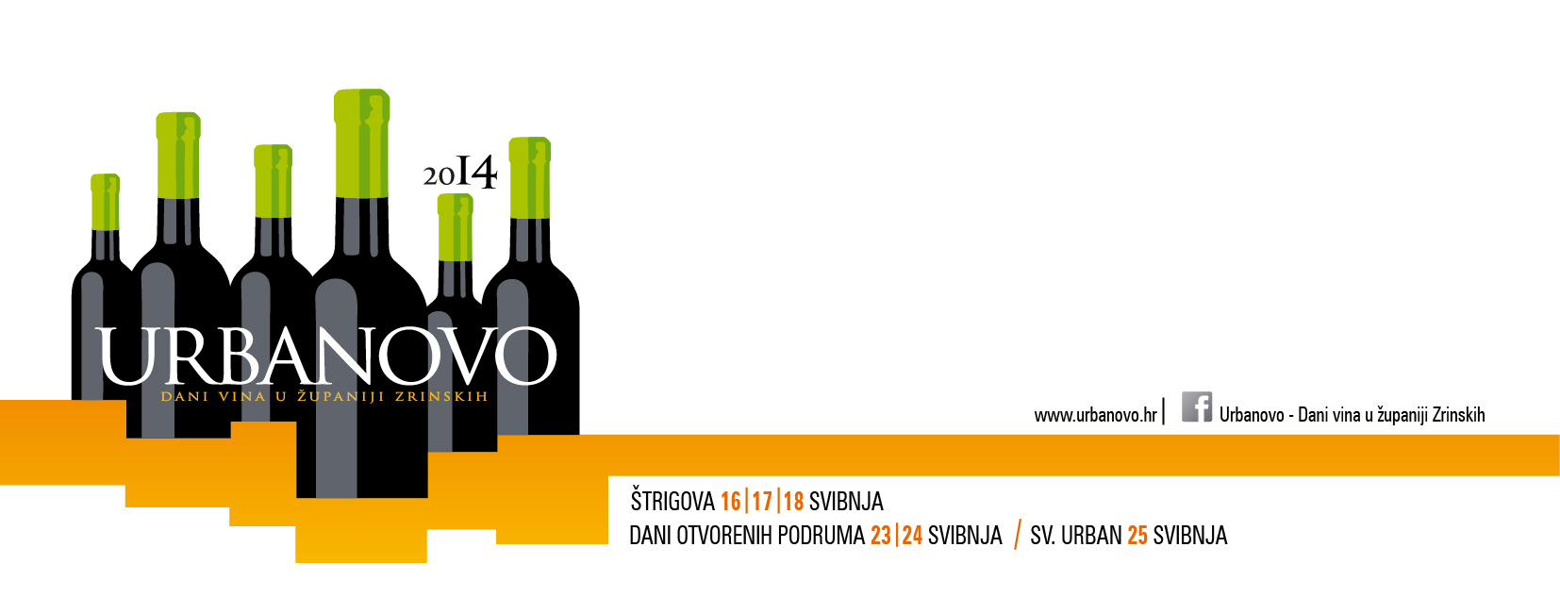
URBANOVO 2014
PRIJAVNICA ZA MEĐUNARODNO OCJENJIVANJE VINA PUŠIPEL/ŠIPON/FURMINT -
BEST OF PUŠIPEL/ŠIPON/FURMINT –
URBANOVO INTERNATIONAL WINE COMPETITION APPLICATION FORM

PODACI O PRIJAVITELJU/INFORMATION ABOUT APPLICANT
______________________________________________________________________________________________________________________________________________________________________________________________
Ime i prezime ili naziv poduzeća (za upis u katalog ocjenjivanja)/First and last Name or Company Name (for catalogue)

_______________________________________________________________________________________  Ulica kućni broj/Address | _______________________________________________________________________________________________  Broj pošte, pošta i država/Postal/ ZIP Code, City, Country
_______________________________________________________________________________________  Telefon/Telefon | _______________________________________________________________________________________________  Telefaks/Fax
_______________________________________________________________________________________  Kontakt osoba/Contact Person | _______________________________________________________________________________________________  E-pošta kontakt osobe/Contact Person E-mail
_______________________________________________________________________________________  Mobilni telefon kontakt osobe/ Contact Person Mobile Number | _______________________________________________________________________________________________  Internet stranica/Website
_______________________________________________________________________________________  Transakcijski račun/Transaction account number | _______________________________________________________________________________________________  ID broj/ID Number

Mjesto i datum/Place and date | Štrigova, 25.04.2014
Krajnji rok prijave/Registration deadline | 22.04.2014.
Rok za predaju uzoraka/Deadline for submission of samples | 22.04.2014.

 |  | PODACI O PRIJAVITELJU/ INFORMATION ABOUT THE APPLICANT
Rbr./No. | Vino/Wine |  | Država/State | Vinorodna regija/Wine growing region | Vinorodna podregija/Wine growing sub-region | Godište/ Vintage | Kategorija vina/Wine category* | Alc. (vol./%) | Reducirani šećer/ Reduced sugar (g/l) | Ukupne kiseline/ Total acidity (g/l) |  | Količina proizvedenog vina/The amount of produced wine (hl)
1.
2.
3.
4.
5.
6.
* Legend: RB redovnaberba/regular vintage, PB predikati/predicate vintage, PV pjenušava vina/sparcling wines.

 |  | OSTALI PODACI/OTHER INFORMATION
Količina vina za ocjenjivanje: za svaki uzorak potrebno je dostaviti po 4 boca vina (1 l ili 0,75 l). Za pakiranja manja od 0,75 l potrebno je dostaviti 6 bocavina/ The amount of wine for evaluation: for each sample must be submitted 4 bottles of wine (1L or 0.75 L). For packages less than 0.75L must be submitted 6 bottles of wine.
Kotizacija za svaki prijavni uzorak iznosi 150 kn ili 20 €. Kotizacija se mora platiti najkasnije prilikom predaje uzoraka (do 22.04.2014.)/Entry fee for each sample is 150 kn (20 €). The registration fee must be paid no later than when submitting samples (up to 22.04.2014).
Molimo da prijavnicu ispunite čitko i da je pošaljete do 22.04.2014. na adresu: TIC Štrigova, Štrigova 29, 40312 Štrigova, Republika Hrvatska ili putem e-maila info@urbanovo.hr/Please fill out the application form readable and send it till 22.04.2014. at the following adress: TIC Štrigova, Štrigova 29, 40312 Štrigova Štrigova, Croatia or via e-mail info@urbanovo.hr
Mjesto i datum/Place and date Pečat/Stamp Potpis/Signature

URBANOVO International Wine Competition is organized by Međimurje County Association of winegrowers and winemakers in cooperation with Međimurje County and support of Association of the winegrowers Jeruzalem from Ljutomer-Ormož wine region and JARA - Public Development Agency of Municipality Ormož (Slovenia)

